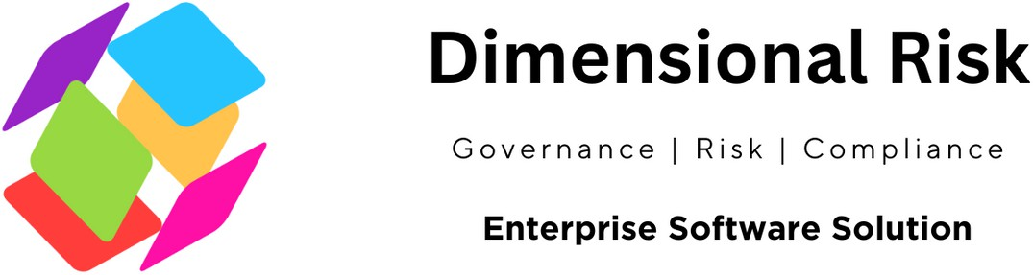

The ISO 31000 Risk Management Checklist serves as a self-assessment tool designed to help organizations identify, assess, and mitigate both external and internal risks. This checklist forms the basis for designing, implementing, and maintaining an effective risk management system that spans the entire organization, making it an invaluable resource for conducting internal audits and ensuring continual improvement in risk management practices.
Company Name Department
Date Date of Sign off
Conducted by Signed off by

Framework
Mandate and Commitment
Have we defined and endorsed a risk management policy?
Yes  No N/A
Have we determined risk performance indicators?
Yes No N/A
Are risk objectives and indicators aligned with organizational objectives and indicators?
Yes No N/A
Have we ensured legal and regulatory compliance?
Yes No N/A

Organization and its Context
In designing our risk framework, have we evaluated the external context?
Yes No N/A
In designing our risk framework, have we evaluated the internal context?
Yes No N/A

Policy Inclusion
Does our policy include a rationale for managing risk?
Yes No N/A

Does our policy clearly define accountabilities?
Yes No N/A
Does our policy specify how conflicts of interest are dealt with?
Yes No N/A
Does our policy link organizational objectives with the risk policy?
Yes No N/A
Is there a commitment to resource risk management in our policy?
Yes No N/A
Is how risk performance is managed, measured, and reported included in our policy?
Yes No N/A
Is there a commitment to review and improve the policy?
Yes No N/A

Accountability, Authority, and Competence
Have we established accountability, authority, and competence for managing risk?
Yes No N/A

Responsibility and Recognition
Do we identify risk owners?
Yes No N/A
Do we identify responsibilities for our framework?
Yes No N/A Do we establish risk responsibilities?
Yes No N/A
Have we established performance measures, and reporting and escalation processes?
Yes No N/A
Do we ensure appropriate levels of recognition for managing risks?
Yes No N/A

General Process
Is the risk management process an integral part of management, embedded in culture and practices, and tailored to our organization?
Yes No N/A
Can we demonstrate communication and consultation with external and internal stakeholders throughout the risk management process?
Yes No N/A
Can we demonstrate that we have considered internal and external context and factors relating to the scope of the risk management process?
Yes No N/A
Have we defined the criteria to evaluate the significance of risk?
Yes No N/A
Have we identified sources of risk, areas of impacts, their causes, and potential consequences?
Yes No N/A
Have we applied appropriate risk identification tools and techniques?
Yes No N/A
Do we use individuals with the appropriate knowledge for risk identification?
Yes No N/A
Do we have processes to analyze causes and sources of risks, their consequences, and the likelihood of these consequences occurring?
Yes No N/A
Do we compare the level of risk found during the analysis process with our risk criteria to determine the need for treatment or further analysis?
Yes No N/A

Integration into Practices
Is risk management effectively and efficiently embedded into our practices and processes?
Yes No N/A

Resource Allocation
Have we allocated appropriate resources for risk management?
Yes No N/A

Consideration of Resources
Have we considered people, organizational processes, methods, and tools?
Yes No N/A
Are documented processes and procedures in place?
Yes No N/A
Do we have information and knowledge management systems?
Yes No N/A Is training provided for risk management? Yes No N/A

Internal Reporting
Have we established internal communication and reporting mechanisms for risk management?
Yes No N/A

External Communication
Have we determined and implemented methods to communicate with external stakeholders?
Yes No N/A

Treatment Options and Planning
Do our processes for selecting treatment options consider stakeholders, legal, regulatory contexts, and other relevant factors?
Yes No N/A
Do we have processes in place to identify new risks introduced through treatment?
Yes No N/A
Does the treatment plan identify a priority order for implementing risk treatments?
Yes No N/A
Do we document how our risk treatment will be implemented?
Yes No N/A
Does our documentation include reasons for selection, expected benefits, responsibilities, proposed actions, resource requirements, performance measures, reporting and monitoring requirements, and timing?
Yes No N/A

Monitor , Review and Continuous Improvement
Yes No N/A
Have we defined responsibilities for monitoring and reviewing risk management activities?
Yes No N/A
Do we check the progress of risk treatment plans regularly?
Yes No N/A
Do we report the results of monitoring and reviewing risk management activities?
Yes No N/A Are our risk management processes traceable?
Yes No N/A
Have we retained suitable records to support risk management activities?
Yes No N/A

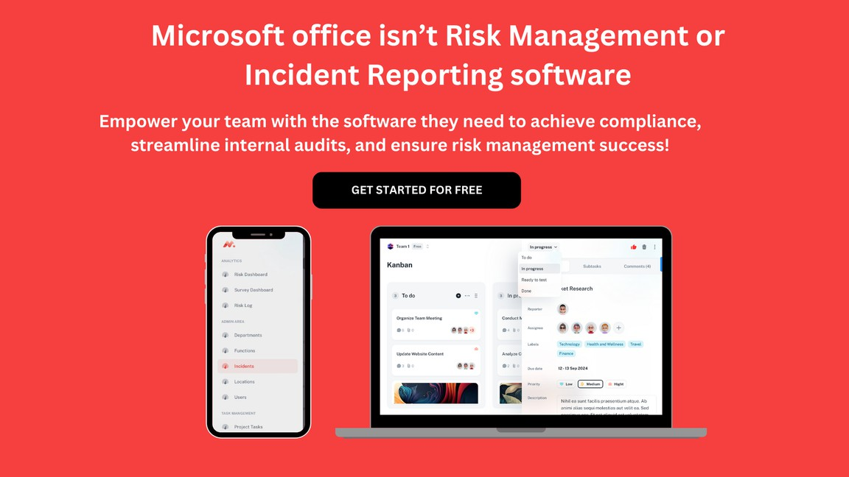


Dimensional Risk
Ga v e r n a nc e | R i s k | C o m p I i a nc e

Enterprise Software Solution

